# Participants’ Past Experiences & Thoughts about Future Sexual Activity

The demographics and attitudes portions of the Pre-Test consist of 12 multiple-choice and check-all-that-apply questions about participants’ experiences and thoughts about sexual activity. Participants could skip questions by selecting “Prefer not to answer”.

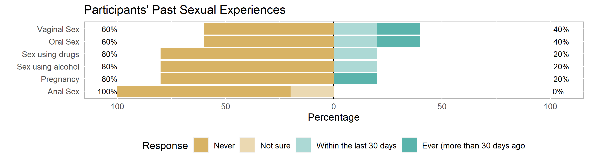

Of the 5 participants who answered these questions on the Pre-Test,

* 2 (or 40% of) participants reported that they have had **vaginal sex** and/or **oral sex**
* 1 participant (20%) reported that they have had sex under the influence of **alcohol** and/or other **drugs**
* 1 participant (20%) reported that they have caused a pregnancy or have been **pregnant**
* none of the participants reported that they have ever had **anal** **sex**, or were not sure if they had

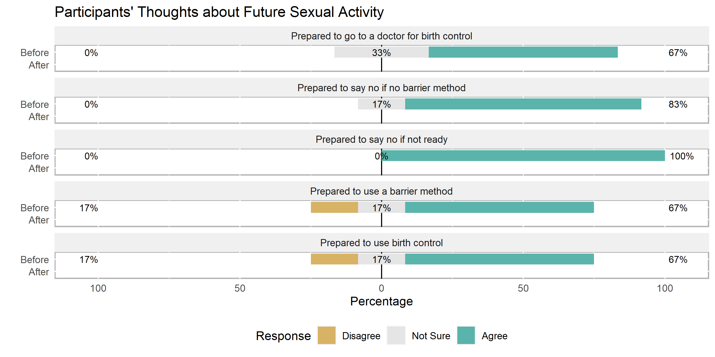

Of the 6 participants who answered these questions on the Pre-Test,

* all 6 (or 100% of) participants agreed that they would be prepared to say no if they **did** **not want to** have sex.
* 5 (or 83% of) participants agreed that they would be prepared to say no if someone wanted to have sex with them **without a barrier method**.
* 4 (or 67% of) participants agreed that they would be **prepared to go to a doctor for birth control, use a barrier method and/or birth control.**
* 1 participant (17%) disagreed that they were prepared to use a **barrier method** and/or **birth control**.

# Participants’ Knowledge about Sexual & Reproductive Health

The knowledge portion of the Pre-Test consists of 16 short-answer, multiple-choice, check-all-that-apply, and true/false questions about relationships, birth control (e.g., IUD, implant, shot, ring, patch, pill), and barrier methods (e.g., condoms, dental dams). Participants could earn partial credit on check-all-that-apply questions for a total of 17 possible points*.

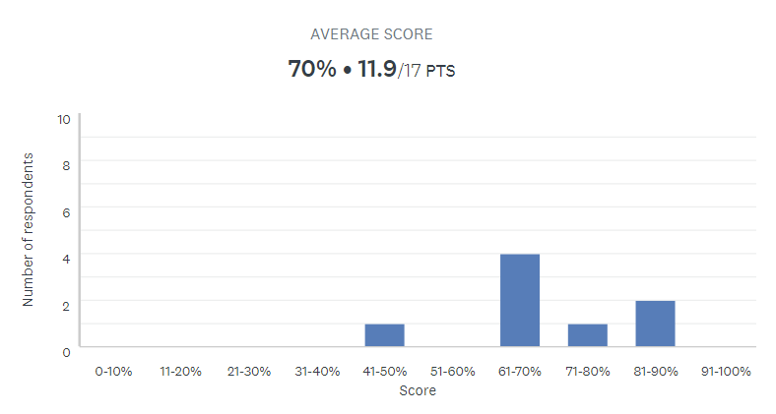

* Range of scores: 47% to 88% correct
* Median score: 68% correct
* Mean score: 12 out of 17 possible points* or 70% correct   
  (right skew: higher-scoring outliers pulling the distribution to the right)
* Mode: 61-80%
* Standard deviation: 13% (some spread of scores)

On average, participants in this group earned 12 out of 17 possible points[1] or answered 70% of the Pre-Test knowledge questions correctly. The following table includes the number of participants (and percent of the group in parentheses) who answered each question correctly. These were the most difficult questions for your group:

# Highlights & Recommendations

|  |  |  |  |
| --- | --- | --- | --- |
| **Question**\* | **Pre- Test** | **Post-Test** | **Notes** |
| Q36: **True** or False? Emergency contraception (like Plan B) can be taken up to 5 days (or 120 hours) after having unprotected sex in order to prevent pregnancy. | 1 (13%) |  |  |
| Q35: True or **False**? Water-based lubricants can cause latex condoms to break. | 2 (25%) |  |  |
| Q26: What is PrEP (Pre-Exposure Prophylaxis)? | 3 (38%) |  |  |
| Q25: Which of the following is FALSE about consent? | 4 (50%) |  |  |
| Q32*: If used correctly, withdrawal (or pulling a penis from a vagina before ejaculating) is effective in protecting people from which of the following? (Check all that apply: **Neither** pregnancy nor STIs.) | 4 (50%) |  |  |

*Participants were able to check-all-that-apply for some questions to earn partial or full credit.

# Participants’ Demographics (for reporting purposes to the Office of Population Affairs)

|  |  |  |
| --- | --- | --- |
| **Reach for DreamCenter032421** | | |
| *Demographics* | | *Count* |
| Gender | | |
|  | Female | 4 |
|  | Male | 3 |
|  | Gender not reported | 1 |
| Race | | |
|  | Black | 4 |
|  | Multiracial | 2 |
|  | Race not reported | 2 |
| Age (years) | | |
|  | 15 | 3 |
|  | 16 | 1 |
|  | 17 | 3 |
|  | 18 | 1 |
| Grade | | |
|  | 9th Grade | 2 |
|  | 10th Grade | 1 |
|  | GED Program | 1 |
|  | Prefer not to answer | 4 |
| Note: n=8. | | |

The group is split in age with half in their mid-teens and half in their late teens. This may impact individual understanding and group rapport if participants’ knowledge and experiences vary greatly, but more knowledgeable participants could also peer-educate or mentor less knowledgeable participants.

Two participants reported LGBQ as their sexual identity. One participant reported a sexual identity not listed in the demographics questions: Pan/Poly. Be aware of language and activities that normalize heterosexual and/or monogamous behavior.

1. Participants were able to check-all-that-apply for some questions to earn partial or full credit.